WEEK-3
Q-1. Write a Python program to generate the first n Fibonacci numbers using a loop.
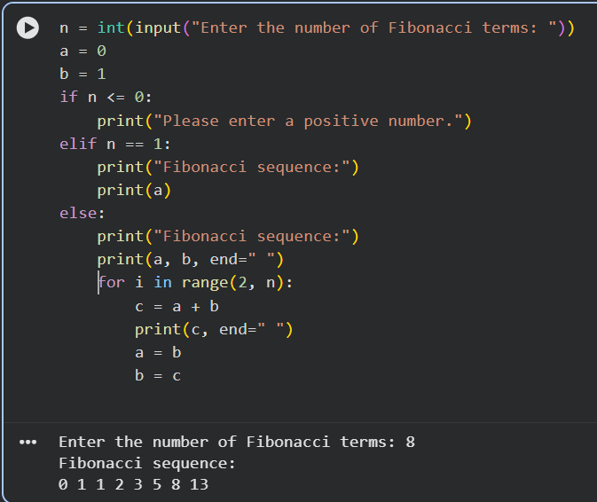
Q-2. Write a Python program to count the number of vowels in a given string.

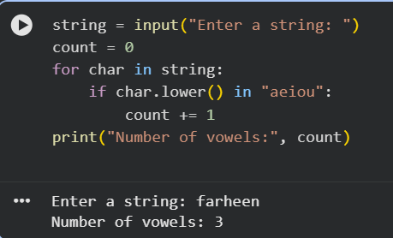

Q-3. Create the following table in HTML with Dummy Data:
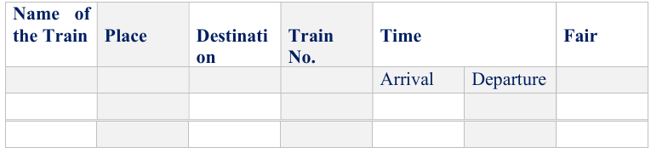
<!DOCTYPE html>
<html lang="en">
<head>
<meta charset="UTF-8">
<meta name="viewport" content="width=device-width, initial-scale=1.0">
<title>Train Table</title>
</head>
<style>
table {
border-collapse: collapse;
width: 80%;
text-align: center;
}
th, td {
border: 1px solid black;
padding: 8px;
}
th {
background-color: #f2f2f2;
}
</style>
<body>
<table>
<thead>
<tr>
<td rowspan="2" >Name of the Train</td>
<td rowspan="2" >Place</td>
<td rowspan="2">Destination</td>
<td rowspan="2">Train No.</td>
<td colspan="2">Time</td>
<td rowspan="2">Fare</td>
</tr>
<tr>
<td>Arrival</td>
<td>Departure</td>
</tr>
</thead>
<tbody>
<tr>
<td>Rahdhani Express</td>
<td>Delhi</td>
<td>mumbai</td>
<td>12981</td>
<td>10:00</td>
<td>10:30</td>
<td>1500</td>
</tr>
<tr>
<td>Shatabdi express</td>
<td>Lucknow</td>
<td>New Delhi</td>
<td>12005</td>
<td>02:00</td>
<td>02:15</td>
<td>1800</td></tr>
</tbody>
</table>
</body>
</html>
OUTPUT:
